TATA CLIQ SALES PROJECT

1. Project Overview

1.1 Objective of the Project
The main objective of this project is to analyse TATA CLIQ sales data and identify meaningful patterns and trends in sales performance. The analysis focuses on understanding revenue generation, customer behaviour, order patterns, and product performance.

1.2 Purpose of the Analysis
The project analyses data related to customers, orders, products, and order details to understand how the business is performing. By analysing these datasets, the project aims to identify high-performing products and categories, understand customer purchasing behaviour, examine sales trends, and determine factors that contribute to overall revenue.

1.3 Tools Used
The following tools and Python libraries are used in this project:
- Python – Used for data analysis and processing.
- Pandas – Used for data cleaning, transformation, merging, and analysis.
- Matplotlib – Used to create graphs and visualisations.
- Seaborn – Used to create informative and attractive statistical visualisations.
- Jupyter Notebook – Used to perform and document the complete analysis.

1.4 What the Analysis Aims to Discover
The analysis aims to discover key business insights such as:
- Overall sales and revenue performance
- Customer purchasing behaviour
- Top-performing products and categories
- Sales performance across different cities
- Popular payment methods
- Monthly and seasonal sales trends
- Customers contributing the highest revenue
- Areas where sales performance can be improved
Overall, the project uses data analysis and visualisation techniques to convert raw sales data into meaningful information that can support better business understanding and decision-making.

Dataset Information
The project uses four CSV datasets to perform the TATA CLIQ Sales Analysis. Each dataset contains different information related to customers, orders, products, and order-level product details. These datasets are combined during the analysis to obtain a complete view of sales performance.

2.1 Customer Dataset
The Customer Dataset contains information about the customers who have registered and made purchases on the e-commerce platform.
Key Attributes
- Customer ID
- Customer Name
- City
- Signup Date

Purpose
This dataset is used to:
- Identify unique customers.
- Analyze customer distribution across cities.
- Examine customer growth over time.
- Study customer contribution to revenue generation.

2.2 Order Dataset
The Orders dataset contains information related to customer purchases. Each order is associated with a unique order identifier and contains transaction-related details.

Key Attributes
- Order ID
- Customer ID
- Order Date
- Payment Method

Purpose
This dataset is used to:
- Track customer purchases.
- Analyze order frequency.
- Examine payment method preferences.
- Study sales trends over time.

2.3 Order Details Dataset
The Order Details dataset contains detailed information about products included in each order. It serves as the transactional dataset that links products and orders.

Key Attributes
- Order ID
- Product ID
- Quantity
- Unit Price

Purpose
This dataset is used to:
- Calculate revenue generated from each order.
- Analyze product demand.
- Measure quantity sold.
- Identify top-selling products.

2.4 Product Dataset
The Products dataset contains information about products available on the e-commerce platform.

Key Attributes
- Product ID
- Product Name
- Category
- Base Price

Purpose
This dataset is used to:
- Analyze product categories.
- Compare product pricing.
- Identify high-performing products.
- Evaluate category-wise revenue contribution.

2.5 Dataset Relationship
The four datasets are interconnected through common identifiers.
Customer and Orders Relationship
The Customers dataset is connected to the Orders dataset using the Customer ID field.
Relationship:
Customer → Multiple Orders
This relationship allows analysis of customer purchasing behavior and order frequency.

Orders and Order Items Relationship
The Orders dataset is linked with the Order Items dataset using the Order ID field.
Relationship:
One Order → Multiple Products
This relationship enables transaction-level sales analysis.

Products and Order Items Relationship
The Products dataset is connected to the Order Items dataset using the Product ID field.
Relationship:
One Product → Multiple Transactions

This relationship helps evaluate product performance and revenue contribution.

3. Exploratory Data Analysis (EDA)
Exploratory Data Analysis (EDA) is performed to understand the structure and quality of the TATA CLIQ sales datasets before generating insights and reports. The EDA process includes data cleaning and data transformation to prepare the datasets for further analysis.
The project works with four main data sets: Customer, Order, Order Details, and Product. Each dataset was examined and prepared before combining the relevant information for sales analysis.

3.1 Data Cleaning
Data cleaning was performed to improve the quality and consistency of the datasets. The major cleaning activities included :
3.1.1 Importing Libraries and Loading Data
The first step involved importing the necessary Python libraries required for data analysis and visualization. Pandas was used for data manipulation, NumPy for numerical operations, and Matplotlib and Seaborn for visualizations.
After importing the libraries, all four datasets were loaded into Pandas DataFrames.
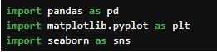
3.1.2 Understanding Dataset Structure
Before performing any cleaning operation, the structure of each dataset was examined using functions such as:
- head()
- info()
- isnull()

These functions provided information regarding:
- Number of rows and columns
- Data types of each attribute
- Presence of missing values
- Statistical summary of numerical columns

This step helped in understanding the quality and completeness of the available data.

3.2 Data Transformation
After cleaning the data, transformation was performed to create useful variables and prepare the datasets for analysis.

3.2.1 Date-Based Transformation
Date columns were transformed to extract useful information such as Month , Year , Day in Month and Quarter. These columns help in analysing sales trends over different time periods.
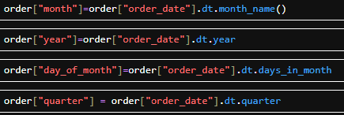

3.2.2 Revenue Calculation
A new revenue column was created in the Order Details dataset.
REVENUE=QUANTITY * UNIT PRICE

3.2.3 Dataset Integration
The Customer, Order, Order Details, and Product datasets were connected using their common identifiers customer_id ,order_id, product_id. This allows customer, order, product, quantity, price, and revenue information to be analysed together.

Insights
Introduction
After cleaning and transformation, the prepared data was used to generate the project's key insights, including total revenue, total orders, total customers, average order value, top products, top customers, one-time customers, payment methods, city-wise revenue, and category-wise revenue.

Revenue Analysis
Revenue is one of the most important indicators of business performance. The analysis revealed the overall revenue generated through product sales during the observed period.
The revenue analysis helped identify:
- Overall sales performance.
- Revenue-generating products.
- Revenue contribution of product categories.
- Revenue contribution of different cities.

Key Findings

- Total revenue generated by the business was ₹18 crore.
- The highest revenue-generating product was Wireless Mouse.
- The highest revenue-generating category was Smartphone.
- The lowest revenue-generating category was Laptop.

4.2 Product Performance Analysis
Product analysis was conducted to understand customer preferences and identify the most successful products.
The analysis focused on:
- Quantity sold.
- Revenue generated.
- Product popularity.
- Category-wise performance.

Key Findings

- The most sold product was Wireless Mouse.
- The highest revenue-generating product was Wireless Mouse.
- The category with the highest sales volume was Smartphone.
- A small number of products contributed a major share of overall sales.
These findings indicate that customer demand is concentrated around specific products and categories.

4.3 Customer Analysis
Customer analysis was performed to evaluate purchasing behavior and identify high-value customers, understanding customer behavior helps businesses improve customer retention and develop targeted marketing strategies.
The analysis examined:
- Customer contribution to revenue.
- Customer distribution by city.
- Top spending customers.
- Customer purchasing patterns.

Key Findings
- The top customer generated revenue of ₹1854728.
- The city with the highest number of customers was Delhi.
- The city contributing the highest revenue was Delhi.
- A small percentage of customers contributed a significant share of total revenue.
This indicates the presence of high-value customers who play an important role in business profitability.

4.4 Geographic Analysis
Geographic analysis was performed to evaluate sales performance across different cities.
Understanding regional performance helps businesses identify profitable markets and expansion opportunities.

Key Findings
- The highest revenue-generating city was Delhi.
- The city with the largest customer base was Delhi.
- Revenue distribution varied significantly across cities.
These findings suggest that certain locations contribute disproportionately to overall business success.

Visualizations and reports
Introduction
Data visualization is an essential component of data analytics as it transforms numerical information into graphical representations that are easier to understand and interpret. Visualizations help identify trends, patterns, relationships, and business opportunities that may not be immediately visible through raw data alone.
The following visualizations were created using Python libraries such as Matplotlib and Seaborn to present the key findings obtained from the e-commerce sales dataset.
  - Top Category by revenue
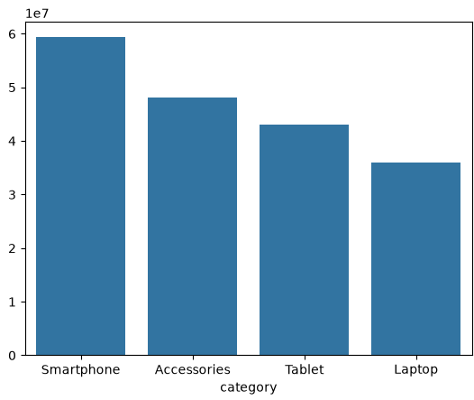
  - Top products by revenue
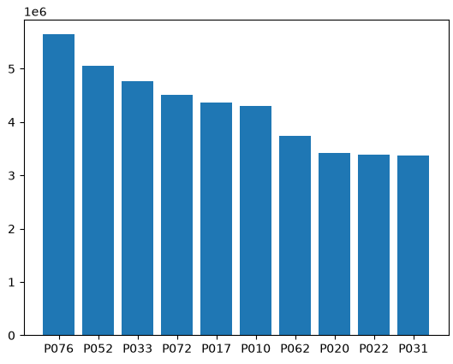
  - Top Products by Quantity
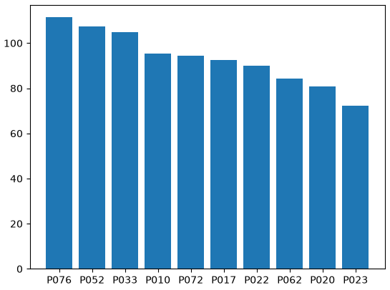
  - Top customers by revenue
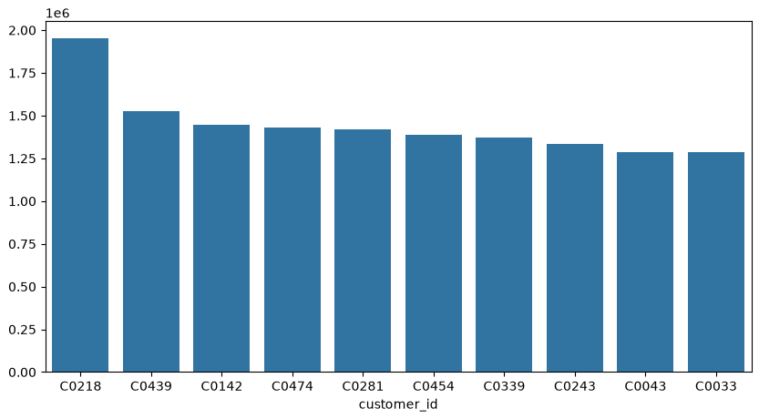

  - Monthly sales
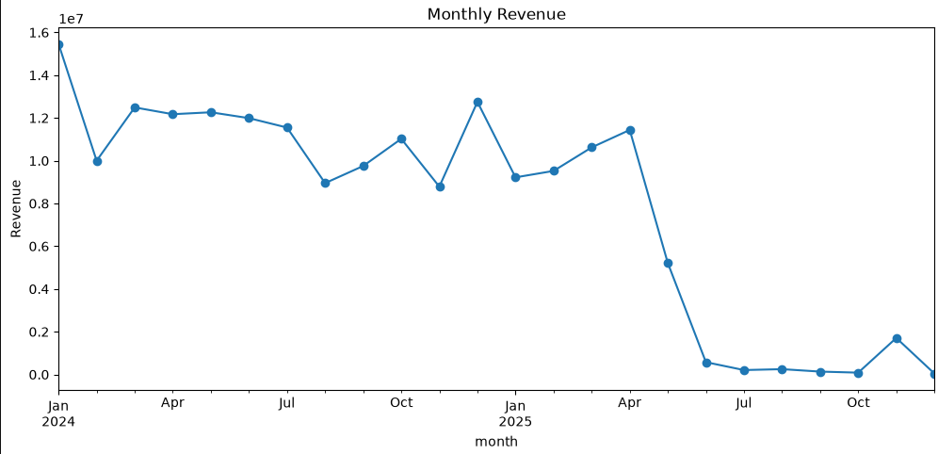
  - Top Customer by revenue
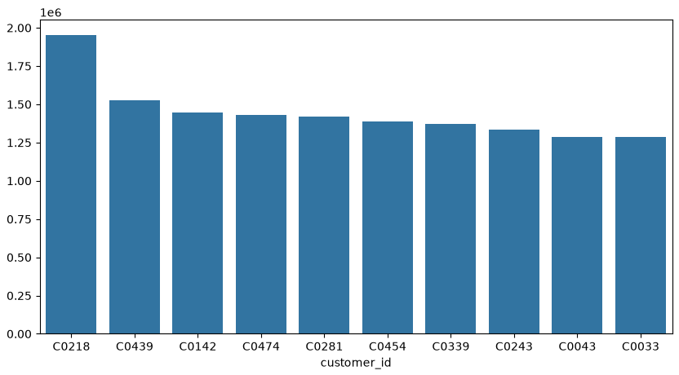
5.7 Top customers by quantity
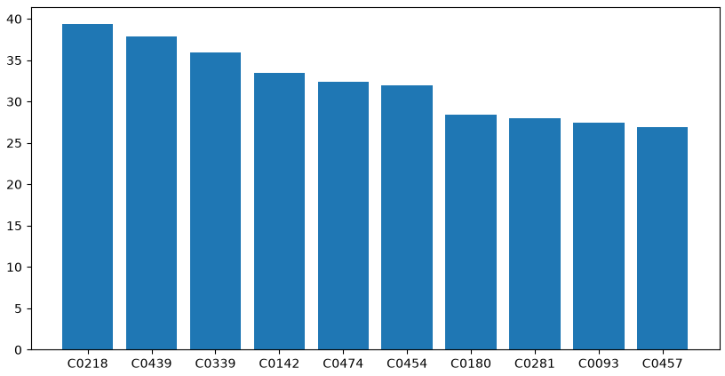

  - Top payment methods
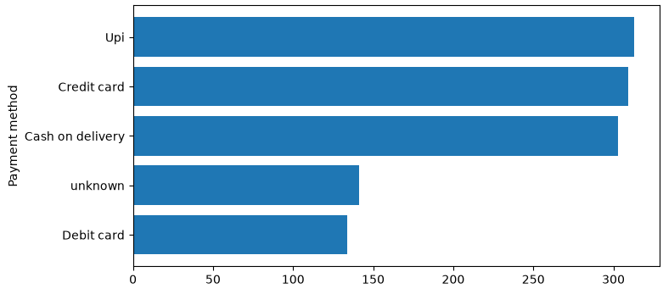

- Conclusion
The project analysed TATA CLIQ sales data to understand customer behaviour, purchasing patterns, product performance and overall sales performance.
The analysis was performed using four datasets: Customer, Orders, Order Details and Products. The datasets were examined, cleaned and connected using common identifiers such as customer ID, order ID and product ID. Revenue was calculated and date-related information such as month, year, day and quarter was extracted for further analysis.
The analysis found that the business generated a total revenue of approximately ₹18 crore during the observed period. The Wireless Mouse was both the most sold product and the highest revenue-generating product. At the category level, Smartphone generated the highest revenue and also had the highest sales volume, while Laptop was the lowest revenue-generating category.
Customer analysis showed that the customer with the highest revenue contribution was customer C0218. Geographic analysis further showed that revenue varied considerably across cities, with Delhi being the leading city in both customer base and revenue contribution. This provides useful information for understanding regional sales performance.
Different visualisations were created to present the findings, including top category by revenue, top products by revenue, top products by quantity, top customers by revenue, monthly sales, top customers by quantity and top payment methods. These visualisations made it easier to identify important trends, compare performance and understand the results.
Overall, the project shows how raw sales data can be transformed into meaningful business information through data cleaning, transformation, EDA and visualisation. The findings can help a business understand its high-performing products, valuable customers, leading cities and purchasing patterns, which can support better product planning, customer engagement and data-driven decision-making.

